Overview of the ASA24® Respondent Websites and
Considerations Related to Data Security and Participant Confidentiality

Updated October 2018
ASA24® is a registered trademark of HHS

Extensive evidence has demonstrated that 24-hour dietary recalls provide the highest quality, least biased dietary data. Traditional 24-hour recalls, however, are expensive and impractical for large-scale research because they rely on trained interviewers and multiple administrations to estimate usual intakes. As a result, researchers often make use of food frequency questionnaires, which are less expensive but contain substantial error.
To address this challenge, investigators at the National Cancer Institute (NCI) created the Automated Self-Administered 24-hour Dietary Assessment tool (ASA24), a freely-available, web-based tool that enables multiple automated self-administered 24-hour recalls and food records. The ASA24 system was developed under contract with Westat®, a social science research firm located in Rockville, MD, and builds on the Food Intake Recording Software System (FIRSSt) developed by Dr. Tom Baranowski of the Baylor College of Medicine. An External Working Group provided advice about the needs and interests of potential users.
The ASA24 system consists of a Respondent Website used to collect recall and food record data and a Researcher Website used to manage study logistics and obtain data analyses. The ASA24-2018 Respondent Website is compatible with mobile devices and is available in English and Spanish. Like the previous 2016 version, the 2018 version allows for the collection of both recalls and food records. This document provides an overview of the methodology and main features of the ASA24-2016 Respondent Website, as well as information on security of the data collected and protections to the confidentiality of the participants of studies that make use of the ASA24 system. Images of the main Respondent site screens are also included.

ASA24 Respondent Website Methodology
Respondents asked to complete a recall are guided through the 24-hour recall interview using a modified version of the United States Department of Agriculture’s (USDA) Automated Multiple-Pass Method (AMPM). The steps in the interview process include:
- Meal-based Quick List
- Meal Gap Review
- Detail Pass
- Final Review
- Forgotten Foods
- Last Chance
- Usual Intake Question
A food record can consist of one or more days as determined by the Researcher during study setup. Respondents are instructed to complete a food record in real time. The methodology for food records was adapted from the ASA24methodology for 24-hour recalls described above.
The steps in the food record process are:
- Meal-based Quick List
- Detail Pass
- Meal Gap Review
Finished reporting for the day? If no, go back to step 1. If yes, go to step 4.
- Final Review
- Forgotten Foods
- Last Chance
- Usual Intake Question

Meal-based Quick List
During the first pass of a 24-hour recall, Respondents are asked to provide a list of the foods and drinks consumed at each meal occasion during the previous 24-hour recall period from midnight-to-midnight or for the past 24-hours (starting at the time of the first login).
For food records, Respondents first provide a list of foods and drinks for the meal they are reporting. After reporting all foods and drinks for that meal, they immediately proceed to the Detail Pass.
Respondents are required to search to find foods, drinks, or supplements; search results can then be filtered if desired. Foods, drinks, and supplements reported at each meal are recorded in the My Foods and Drinks panel within the instrument. In addition to selecting an eating occasion (e.g., breakfast, lunch, snack), Respondents are also prompted to specify the time of the occasion before reporting the foods and drinks consumed. The Researcher can opt to collect additional contextual information including where meals were eaten, television and computer use during meals, and whether the meal was eaten alone or with others by turning on the corresponding module during study setup.

Meal Gap Review
For 24-hour recalls, once Respondents finish creating their My Foods and Drinks list at the end of the Quick List step, they are asked if they consumed anything during any 3-hour gaps between eating occasions. For a food record, the Meal Gap Review follows the Detail Pass. For the midnight-to-midnight version of a 24-hour recall and for food records, Respondents are also asked if they consumed anything between midnight and the first eating occasion, and between the last eating occasion and midnight regardless of the length of time gaps. During a Gap Review, Respondents have the opportunity to return to the Quick List pass to add a meal(s) and the foods, drinks, and supplements consumed at them.

Detail Pass
Respondents are asked for details about the foods and drinks they recorded during the Quick List, including form (e.g., raw), preparation methods (e.g., grilled or roasted), the amount eaten, and any additions (e.g., sugar, coffee cream, salad dressing). An option is available to probe Respondents about the source (e.g. grocery store, farmer's market, etc.) of where reported foods and drinks were obtained.

Final Review
Respondents are prompted to review all of the foods and drinks reported for the intake day, and make edits and add meals, foods, drinks, and supplements as necessary.

Forgotten Foods
Following the Final Review, Respondents are asked questions probing about the consumption of commonly forgotten foods and drinks (e.g., snack foods, fruits, vegetables, cheese, water, coffee, tea) and supplements. Respondents must select either "Yes" or "No" for each food or drink probed. For any "Yes" response, the Respondent will be returned to the Quick List to add the forgotten item(s).

Last Chance
After Forgotten Foods, Respondents are asked if they have reported all that they consumed. If Respondents want to add more foods, drinks, or supplements, they will be returned to the Quick List to add more items; otherwise, they will move forward to the Usual Intake Question.

Usual Intake Question
The final question asks: Was the amount of food that you ate yesterday more than usual, usual, or less than usual? This question probes whether this was a typical day's intake.

Supplement Module
Supplements include vitamins, minerals, and other supplements including prescription supplements. The supplements included are based on those reported in the National Health and Nutrition Examination Survey (NHANES). This module can be turned on or off by the Researcher during study setup. Respondents are able to report supplements similar to how they report foods and drinks throughout the day as part of a meal regardless of whether the module is turned on or off. However, if the module is turned on, Respondents are cued in several places to include supplement intakes in their report.

Respondent Nutrition Report
For 24-hour recalls or food records collected using ASA24-2018 system, Researchers can select an optional module to allow Respondents to receive a Respondent Nutrition Report. This Report provides information to Respondents regarding how their intake on a single reporting day compares to U.S. dietary guidance and nutrient requirements. Note that at this time, the Respondent Nutrition Report is available in English and Spanish for 24-hour recalls; however, for food records, it is only currently available in English.
When this optional module is selected by Researchers, after they have completed their 24-hour recall, Respondents will be asked if they would like to obtain a Nutrition Report about that day. Respondents who answer affirmatively are asked their age and sex, and if female, if they are pregnant or lactating. The ASA24 system then presents Respondents with a Nutrition Report. The Respondent Nutrition Report provided to Respondents is also available to Researchers on the Researcher website. Note that the Respondent Nutrition Report will only be generated if the Respondent provides their age, sex, and pregnancy/lactation status.

ASA24 Respondent Website Features
The ASA24 Respondent Website guides the participant through the completion of either a 24-hour recall for the previous day or a single or multiple day food record. The ASA24 instrument:
- Flows as per modified United States Department of Agriculture (USDA) Automated Multiple-Pass Method (AMPM) for 24-hour recalls, which was further adapted for collection of food records;
- Allows researchers to specify timing of recall, either from midnight-to-midnight or for the past 24-hours from time of login;
- Asks Respondents to report eating occasion and time of consumption;
- Enables Respondents to search to find foods, drinks and supplements;
  - Presents Respondents with search results for misspelled and related food items;
  - ASA24-2018 includes >13,670 misspellings and synonyms;
- Asks detailed questions about food form, preparation, portion size, and additions using an extensive branching question database with greater than 13 million pathways so that food codes can be assigned;
- Uses images to assist Respondents in reporting portion size;
- Allows the Respondent to add or modify food, drink, and supplement choices at multiple points during the recall or record;
- Includes optional modules to query where meals were eaten, whether meals were eaten alone or with others, television and computer use during meals, and source of foods consumed;
- Includes an optional module to query dietary supplement intake;
- Is available in English and Spanish;
- Offers an optional Respondent Nutrition Report that Researchers can choose to make available to Respondents. The Respondent Nutrition Report provides feedback on nutrient and food group intake in comparison with U.S. dietary guidance. This report is available in English or Spanish for Respondents completing food recalls ASA24-2018, and English only for Respondents completing food records.
- Is accessible by individuals using assistive technologies, such as screen readers.
- Provides a means for Respondents to report, save, and modify recipes.
Data Security and Protections to Confidentiality of Participants Using the ASA24 System
Researchers using the ASA24 system do not provide the NCI, Westat, or the ASA24 system with any identifying data for participants of their studies. Rather, researchers specify a unique numeric identifier for each Respondent and download system-generated usernames and encrypted passwords that they provide to Respondents so that they may access the application.
The ASA24 system also does not collect any identifying data directly from Respondents. However, IP address information is accessed for the purpose of routing information between the server and the respondent's computer—often the IP address is that of the user's Internet Service Provider (ISP). IP addresses are not stored or tracked by the ASA24 system. However, logs of connections are kept in the hosting environment for audit trail purposes. This information is not mined in any way but would be available if there were a legal obligation to release it.
Response data are secured at the hosting site using industry standard security controls, including firewalls and encryption. All data entered into the ASA24 system at the Respondent’s computer is encrypted by the internet browser (e.g., Internet Explorer, Firefox) before they are transmitted to our servers using Secure Socket Layer (SSL) Technology. SSL allows for the authentication of the sending and receiving computers.
Only a particular study’s investigator(s) and the ASA24 operations team can access response data. Access is gained through usernames and strong passwords.

ASA24 Respondent Website Screen Shots
Screen layouts will vary depending upon the screen size of the device.
Figure 1: The Respondent can choose to complete the ASA24 records or recalls in English or Spanish.
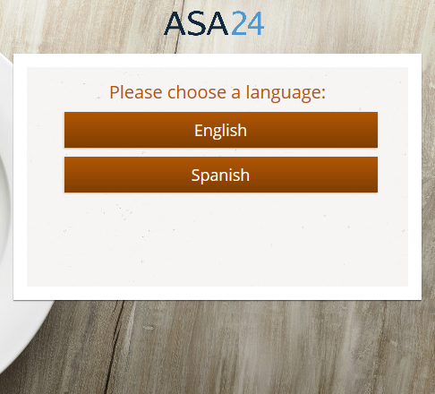
Figure 2: An introductory screen prompts the participant to report everything that she or he had to eat or drink for the desired period.
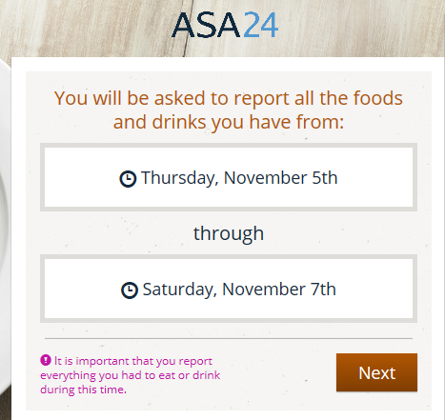
Figure 3: The meal details screen collects information on the eating occasion and time, and displays optional modules that can be selected by the researcher to query where meals were eaten, whether meals were eaten alone or with others, and television and computer use during meals. This is the first step in the meal-based Quick List.
Figure 4: The Find Foods & Drinks screen is used to select foods, drinks, and supplements to be added to a meal during the Quick List Pass during the reporting period assigned by the Researcher.
Figure 5: Respondents complete the Quick List pass by adding meals and selecting foods, drinks, and supplements. The food, drink, and supplement terms are based on the National Health and Nutrition Examination Survey (NHANES).

Figure 6: In a recall, after the Respondent reports the foods, drinks and supplements consumed and selects the Next button in Figure 5, gaps between meals are identified (Meal Gap Review pass) After reviewing the gaps, the Respondent selects the ‘Add Details’ button.
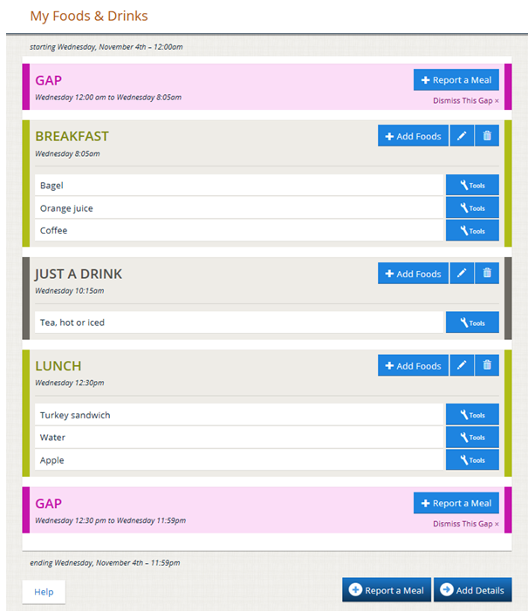
Figures 7a-c: The detail pass prompts the Respondent to report the details of each food, drink, and supplement including the specific type or how it was prepared, anything added to it, and the amount that was consumed.
Figure 7a.
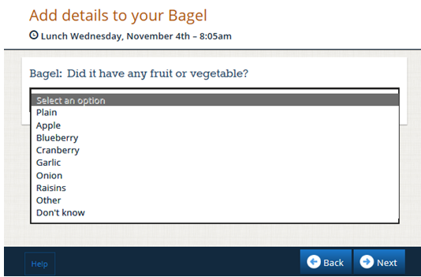
Figure 7b.
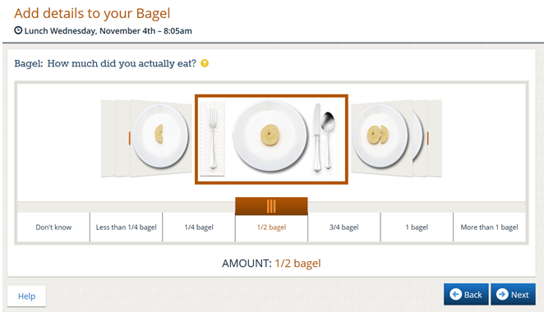
Figure 7c.
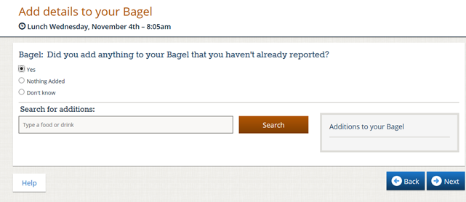
Figure 8: Once the Detail Pass is complete, the Final Review begins. The Respondent can make changes to the details for a given food or drink and add more foods and drinks if necessary.
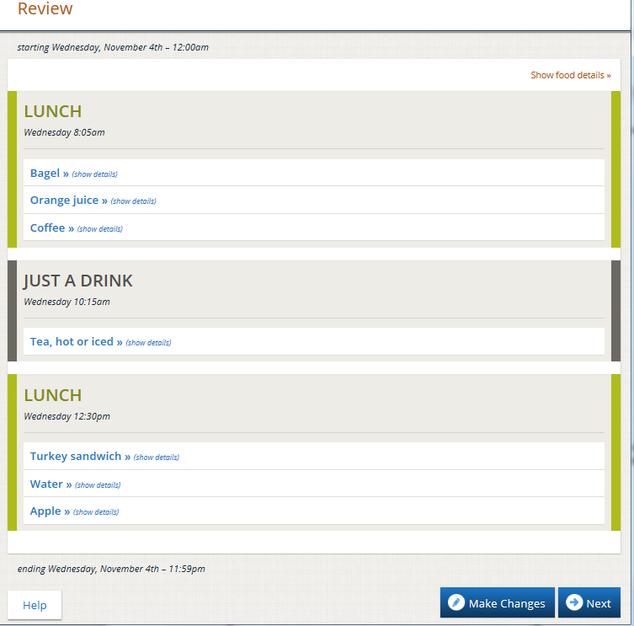
Figure 9: The forgotten foods pass queries the Respondent about frequently forgotten foods. Responding yes to one or more categories will result in a prompt to add the forgotten foods or drinks.
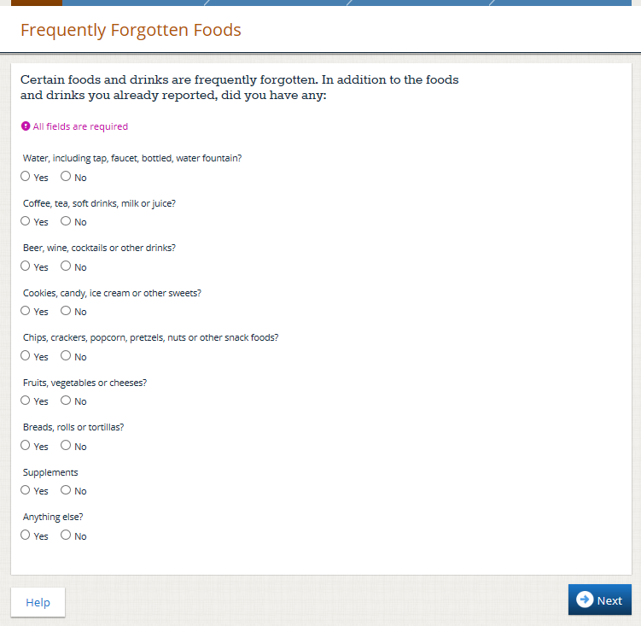
Figure 10: The Last Chance Pass provides Respondents one more opportunity to edit their intake.
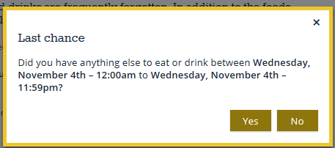
Figure 11: The final question in the food and drink module asks the Respondent whether the amount of foods and drinks consumed yesterday was usual.
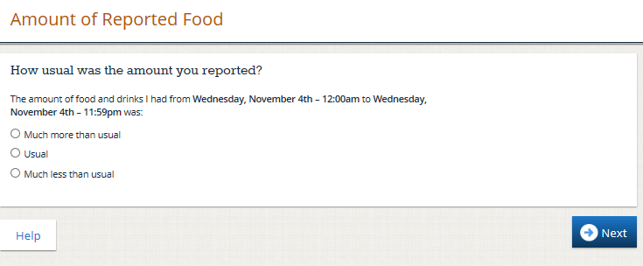
Figure 12: Once the Respondent completes the food and drink module and the supplement module, if selected by the researcher during study set up, his or her responses are saved in the secure database and he or she can exit the ASA24 system* Only the Researcher(s) who are registered to that study and the ASA24 operations team can access the response data.

*12b. If the Researcher chose to include the option of providing a Respondent Nutrition Report (RNR) at the end of diet recall or food record entries, participants are given the option of answering a few basic questions in order to receive a copy of their nutrition report. To view a sample of an RNR, visit https://epi.grants.cancer.gov/asa24/respondent/nutrition-report.html.
Questions presented to the participant in advance of creation of the Respondent Nutrition Report include whether the participant would like to view the report, and if yes, they are asked to provide their age, gender, and whether participant is pregnant or lactating, as depicted in the figures below.

